**Login Credentials**

**Username:** Sarah

**Password:** Sarah123

EMAIL:smukaneza9@gmail.com

**How Project Works**

**Project Overview**

The SarahTech Content Writing Services project is a web application designed to provide users with information about content writing services offered by SarahTech. The project includes features such as user registration, login, logout, and various informational pages. The application is built using HTML, CSS, JavaScript, and PHP.

**Project Structure**

The project is organized into several files and directories:

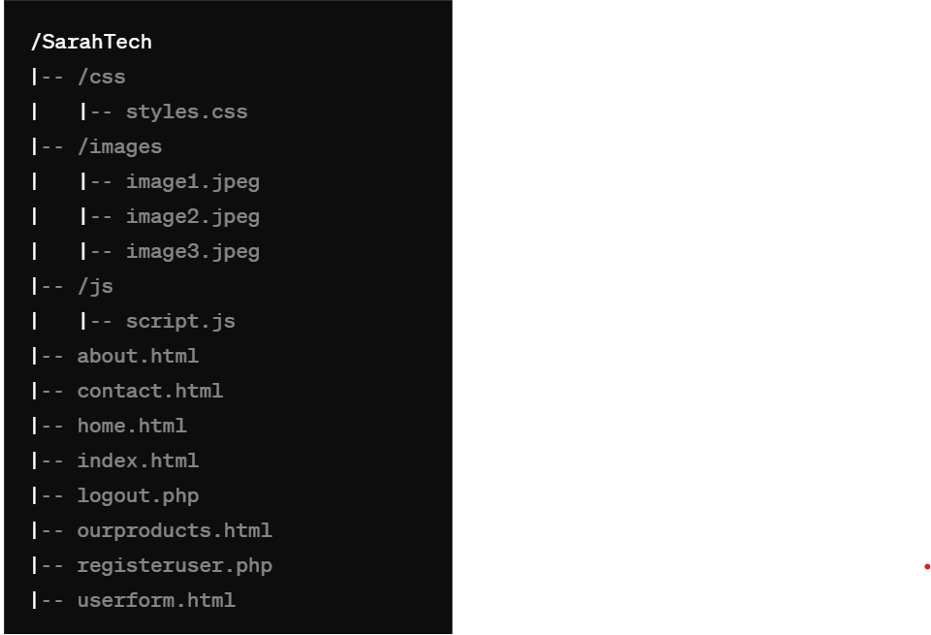

**File Descriptions**

* **/css/styles.css**: Contains all the CSS styles for the project.
* **/images/**: Contains image files used on the website.
* **/js/script.js**: Contains JavaScript code for client-side functionality.
* **about.html**: Page with information about the company.
* **contact.html**: Contact page with company contact information and social media links.
* **home.html**: Homepage of the website.
* **index.html**: Main landing page with navigation to other pages.
* **logout.php**: PHP script to handle user logout.
* **ourproducts.html**: Page displaying information about the products offered.
* **registeruser.php**: PHP script to handle user registration.
* **userform.html**: Registration form for new users.

**Functionality**

1. **User Registration**: Users can register by filling out a form on **userform.html**. The form submits data to **registeruser.php**, which processes the registration.
2. **User Login**: Users can log in by providing their username and password. This functionality can be handled via a login page and script (not provided in the initial setup).
3. **Logout**: The **logout.php** script handles user logout by destroying the session and redirecting to the login page.
4. **Navigation**: Users can navigate between different pages using links provided on each page.
5. **Contact Information**: The **contact.html** page provides contact details and social media links for the company.
6. **Image Gallery**: The **index.html** page includes an image gallery with hover effects.

**Usage**

**Registration**

1. Navigate to the registration page (**userform.html**).
2. Fill in the required fields: Username, Email, and Password.
3. Submit the form to register a new user. The **registeruser.php** script processes the data and stores it in the database.

**Login**

1. Navigate to the login page (not provided in the initial setup).
2. Enter your username and password.
3. Submit the form to log in.

**Logout**

1. Click on the logout link in the top right corner.
2. The **logout.php** script will log you out and redirect you to the login page.

**Navigation**

* Use the navigation links in the **.container** div to access different pages such as Home, About Us, Our Products, Contact Us, and Register.

**Contact Page**

1. Navigate to the **contact.html** page to view contact information.
2. Click on the social media links to visit the respective social media pages.